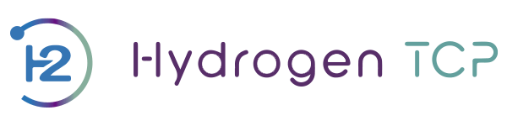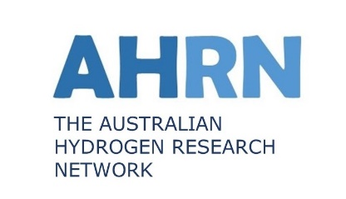

Report from the 100th IEA H2 TCP Exco meeting
Paris, 3-5 November 2025
Andrew Dicks and Liezl Schoeman attended the 100th EXCO meeting in Paris on 4th and 5th November. This was preceded by a 1-day review on 3rd November of the history of the IEA Hydrogen TCP celebrating the past 50 years of the IEA and the Hydrogen TCP. On this occasion the EXCO was joined by many other hydrogen stakeholder – from organizations in Europe and elsewhere. The day was arranged around 5 round-table discussions:
- Hydrogen production and storage – led by Marcel Weeda, vice chair of the Hydrogen TCP
- H2 infrastructure, Transport, Conversion and Safety - Stephanie Tracy, vice chair of the Hydrogen TCP
- Delivering value through collaboration – Pual Lucchese, Chair, Hydrogen TCP
- Reflections on 48 years of global cooperation and future needs – Amalia Pizzaro, IEA Energy Technology Analyst

These panels were alternated with various presentations and videos from previous H2 TCP exco and task meetings.
The event was concluded by a dinner at the museum of arts and sciences which started with a tour of the exhibits.
The following summarises the 100th Exco meeting and I have highlighted in red items that are significant for Australia.
On General Business:
- The sessions were recorded, and both the recordings and the presentations used are available in the private area of the website and in the shared folder.
- 99th ExCo Meeting Minutes were approved with no comments.
- On May 20, 2025, a written procedure was sent regarding the nomination for the position of Vice Chair of the Hydrogen TCP.
- On October 16, 2025, a written procedure was sent to approve the H2TCP Communication Plan. The procedure is still open. The deadline for submitting changes or suggestions is November 24, 2025.

On the IEA Hydrogen TCP Strategic Discussions
Task 47: Certification of Hydrogen and Derivatives – R&D:
- The following steps were approved by the ExCo Members present (with no votes against):
- The document developed under the Task, “Mutual Recognition Framework”, will first be reviewed by the Task experts and subsequently by the ExCo Members. This version will be considered the final document of the Task.
- The final document will be shared with IPHE to enable them to continue the work.
- The Task will then be formally closed.
TRL Assessment:
- The following steps were approved por mayoría by the ExCo Members

Proposal for 2026 activity:
- Launch a public tender to select an external entity (company or university) to implement the two phases of the activity planned for 2026.
- Involve ExCo Members in the review process of the technology briefs and related forms.

- The Technical Secretariat will send the tender proposal to the ExCo Members so that they may disseminate it among their contacts.
- It was highlighted that the content and methodology must be clearly defined to ensure comparability and that efforts should be coordinated with the IEA.

IEA Hydrogen Coordination Group
- The Technical Secretariat will share the draft of the Global Report with ExCo Members for the review of the chapters, expectedly at the beginning of January 2026.
- A section will be added addressing the main challenges on collaboration.

Handbook Update
Regarding the process for adopting the final text, it was decided that the review will not be carried out chapter by chapter, and that the Leadership Team will determine how to proceed when defining the final text presents challenges.

On IEA Hydrogen TCP Priorities
A procedure will be developed to establish how future selections of priority topics to be funded will be conducted, to be presented at the next ExCo Meeting:
- Clearly define the amount of funding available for these types of initiatives.
- Identify possible funding options.
- Prepare a preliminary list of priority ideas for the H2TCP.
- The funding will be a one-time allocation, not a recurring one.
Sunlight to X
- It was decided that the work on this topic should continue.
- A proposal may be presented at the next ExCo Meeting.
- ExCo Members that have expressed interest in principle: Austria, Italy, Spain, South Korea, China, The Netherlands.
Proposal – Liquid Hydrogen:
It was decided to wait until the next ExCo to see whether additional proposals are submitted and then vote on which ones are of greatest interest to be financed by the TCP.
Collaboration with ISGAN
It was decided that the final document submitted by ISGAN will be reviewed to verify that the comments provided by the ExCo in the first review have been incorporated.
The ExCo Members will have until the end of November to send their comments to the Technical Secretariat.

Electrolyser Working Group:
- Germany and Australia expressed their interest in participating in the Working Group.
- It was recommended that the Working Group address topics not covered by Task 30: Electrolysis of the AFC TCP, in order to avoid overlap and promote collaboration.
- Further information will be shared at the next ExCo Meeting, where the final results will also be presented.
On Action Plan:
- The Technical Secretariat will send an email to call for volunteers to establish an AI Working Group.
On the budget 2026:
- The Technical Secretariat will send the budget proposal to the ExCo Members for approval via Written Procedure.

On Tasks
Task 43:
- The Task Manager will submit the new work plan of the Task, which will include the addition of a new Subtask on Detection, to be approved by the ExCo through a written procedure.
PP SMM&VP + Task 42 follow up:
- It was decided that the Work Plan will be shared with the ExCo Members for approval through a written procedure.
Task 46:
- It was agreed to wait until the next ExCo Meeting to determine whether the Netherlands will be able to lead the Task.

TiD Hydrogen for Iron and Steelmaking:
- The proposal was approved under the name “Task 52”, with no votes against.

